ADDITION OF NUMBERS

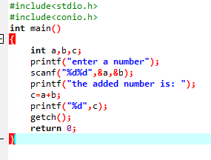

OUTPUT

